Basic psql Commands

Connecting to PostgreSQL via psql
psql is an interactive terminal for working with PostgreSQL. It allows you to connect to a database, execute SQL queries, and use special meta-commands.
General structure of connection command:
psql -h <host> -p <port> -U <username> -d <database>

-h - server address (default localhost)
-p - port (default 5432)
-U - PostgreSQL username
-d - database name

If the database and user match the name of your OS, you can simply call psql.

Examples:
# 1
psql -U postgres -d mydb -h localhost -p 5432
# 2
psql -U postgres -d mydb -h localhost -p 5432
# 3
psql -U postgres -d mydb
# 4
psql -h localhost -U postgres -d mydb

Meta-commands in psql:
Meta commands begin with a backslash (\). They allow you to manage database without SQL queries.

Basic meta commands:
- \l - list all databases
- \c <dbname> - connect to a database
- \dt - list all tables in the current database
- \d <table> - description of the table structure (columns, types, keys)
- \q - exit psql
- \h - help on SQL commands (for example: \h SELECT)
- \? - list of all meta commands
Examples:
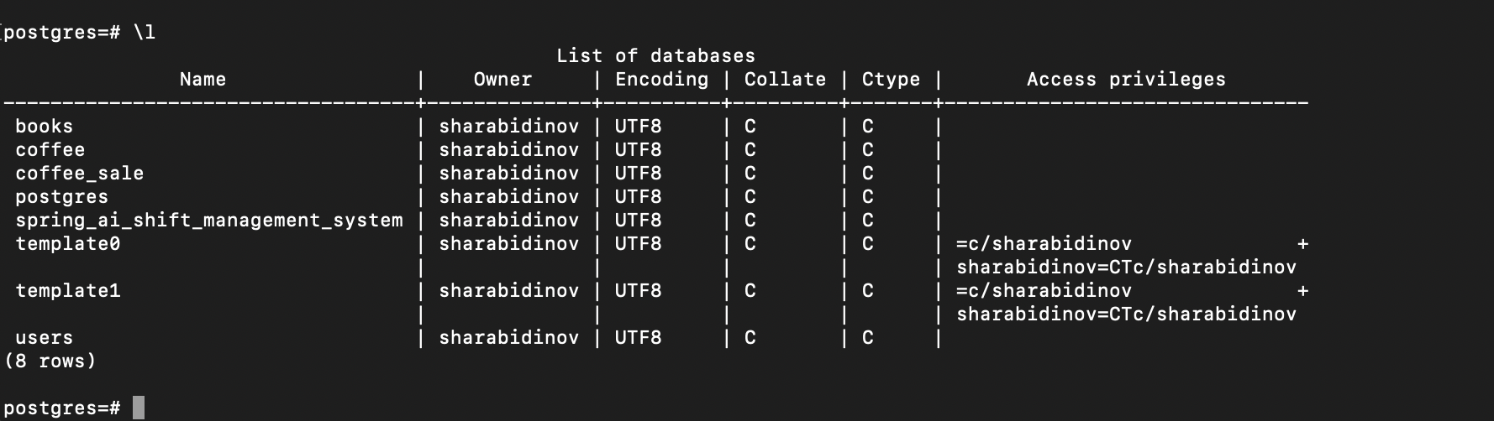
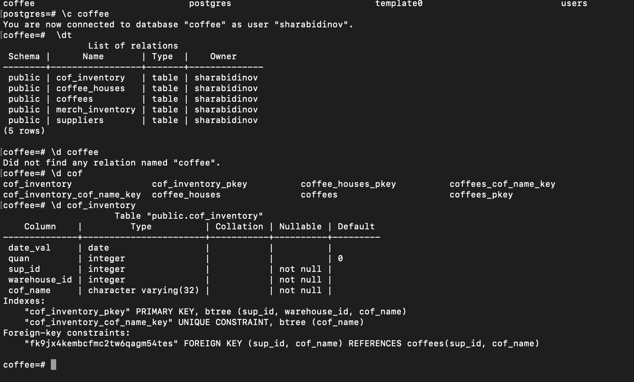

Basic Command-Line Operations:
You can run SQL queries directly from the terminal using psql.

Example:
-- create data
CREATE TABLE students (
id SERIAL PRIMARY KEY,
name VARCHAR(100),
age INT
);
-- insert data
INSERT INTO students (name, age) VALUES ('Alice', 21), ('Bob', 23);
-- select data
SELECT * FROM students;
-- delete table
DROP TABLE students;

Exit from psql:
if you want to exit from psql console, type command bellow:
\q

